|  |
| --- |
| Middle School |
| **STUDENT NAME:**   **CLASS: _______**  **TEACHER NAME:** |

|  |  |  |  |
| --- | --- | --- | --- |
| **UNIT: Chance and Data**  **ISSUE TOPIC Data – Collecting and Using Data**  **ASSESSMENT TASK: Investigation**  **ASSESSMENT DESCRIPTION: This investigation consists of 4 sections.**   * Section A – Thinking and Reasoning * Section B: - Knowledge and Understanding * Section C: - Knowledge and Understanding * Section D – Thinking and Reasoning   **CONDITIONS OF ASSESSMENT:**   * **Length: 2 weeks – the amount of class time to be determined by the teacher.** * **The use of publishing software is expected ie spreadsheet, word processing.** | |  | **Mathematics** |
|  |
| **YEAR**  **2010/2011**  **TERM 1**  **TASK: Investigation**  ***‘What’s in a Name?’*** |
| **SUMMARY OF RESULTS** | |
| **CRITERIA ASSESSED** | **STANDARD** |
| **THINKING & REASONING** |  |
| **KNOWLEDGE & UNDERSTANDING** |  |
| **COMMUNICATING** |  |
| **OVERALL RESULT** |  |

***Context:***

You work for a company which specialises in corporate data analysis (Numbers ‘R Us).

You have been approached by a global plastics company (Characters ‘n’ Toons) which produces, among other items, pencil cases.

They wish to produce a range of ‘Ben 10’ and ‘Princess’ pencil cases for junior school students.

The pencil cases are **‘letter-insert’** style, which means that small pockets are on the front that allows a student to place individual letters to create their name.

Samples of the proposed pencil cases have been sent to you, as seen below.

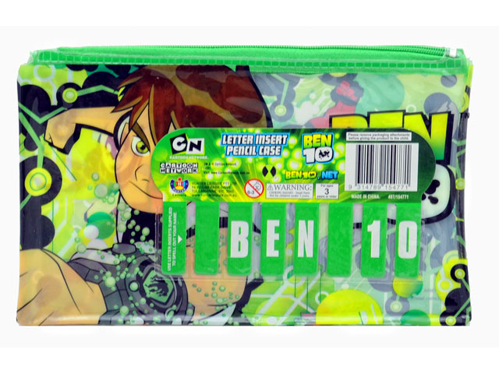 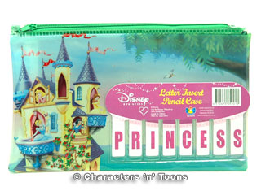

At the moment, the pencil cases allow for 8 letters to be inserted to create the child’s name. The company is unsure if this is sufficient for students in the UAE.

Obviously, the company wants to make as much profit as possible from their products, and the cost of production is higher for every extra insert on the front of the case.

In other words, the company could put 3 inserts on the front, but that may not allow many students to construct their name. They could put 20 inserts on the front, but this becomes too costly.

**Task 1 – Recommend, based on evidence, the least number of letter spaces that should be created on the front of the pencil case to accommodate most names of students in the UAE.**

The company also needs to provide one or more sheets of perforated letters that can be inserted in the spaces. Again, creating too many sheets of letters per pencil case becomes costly. Too few will mean that not many pencil cases would be sold.

**Task 2 – Recommend, based on evidence, the number of each of the 26 letters of the alphabet that should be provided with each pencil case.** This should also give the total number of letters printed for each pencil case. Also describe how many sheets, and how many letters per sheet, should be printed.

**As you are making a professional presentation to the company, your responses to this brief must be typed. You could also use the functions within a spreadsheet to enhance your presentation.**

***Section A – Thinking and Reasoning***

*(Develops hypotheses and predictions based on length of, and characters in, a name..)*

Before collecting your data and analysing the results, **predict;**

1. the average length of student names that you would expect to find
2. the most frequently occurring length of student name
3. the least number of letter spaces that should be created on the front of the pencil case.

**Describe** how you arrived at your predictions. **Explain** your reasoning and thinking.

**Create** a table to predict the number of each of the 26 letters of the alphabet that should be provided with each pencil case. The table should show a total number of letters.

C:\Users\jason\AppData\Local\Microsoft\Windows\Temporary Internet Files\Content.IE5\P5I16F5J\MC900097939[1].wmf

Again, **describe** how you arrived at your predictions.

***Section B – Knowledge and Understanding***

*(Uses suitable representations and descriptive statistics to simplify data interpretation.)*

You need to **collect** data from an appropriate sample.

You must **summarise** the data and **present** it using tables and/or graphs.

You must also **compare** your summary data to another student’s summary data and **describe** the similarities or differences that you find.

C:\Users\jason\AppData\Local\Microsoft\Windows\Temporary Internet Files\Content.IE5\6ASDAHKV\MC900312664[1].wmf

Data that you must collect and summarise include;

1. The number of students in your sample
2. A table and graph showing the length of first names
3. A count of the number of letters used in your sample

***Section C – Knowledge and Understanding***

*(Uses simple measures of spread and centre to make inferences.)*



**Calculate** the mean, median, mode and range of your collected data, if relevant.

Which measure of location do you think is best for representing your data, and why?

***Section D – Thinking and Reasoning***

*(Evaluates own thinking and reasoning using collected data.)*

What are your recommendations to ‘Characters ‘n’Toons’? (Refer to **Task 1** and **Task 2**)

**Justify** your recommendations based on your data as evidence.

Are your results an accurate representation of all students in the UAE. Why/not?

**Compare** your predictions with your data and calculations. Did you find any surprises?