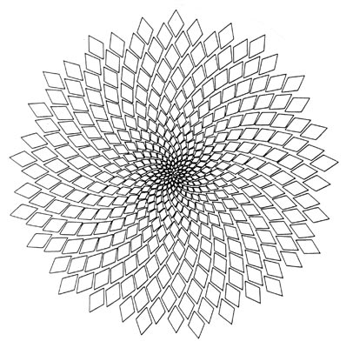
Name: _____________________________
Class: _____________________________
Due Date: __________________________

The Math Behind Beauty

What has mathematics got to do with beauty? Actually, a lot! Physical beauty and aesthetic appeal depend on ratio. Beauty can be defined in terms of symmetry and proportion and it can be measured. In this investigation, you will examine the mathematics behind perfect form.

Part A: Biometric Data
Let’s experiment with some special ratios found on the human body
Question 1- With 4 of your classmates complete the following table.
 | You | Student1 | Student2 | Student3 | Student4
Height
Arm Span (fingertip to fingertip)
Length of head from hairline to chin
Length of foot
Length of forearm
Width of mouth
Distance between eyes (pupil to pupil)
Width of eye
Length of hand

Question 2 - Using the information from question 1, complete the following table using ratios (do your calculations on a separate sheet of paper- remember to simplify!).
 | You | Student1 | Student2 | Student3 | Student4
Height : arm span
Height : length of head
Length of foot : length of forearm
Length of hand : height of face
Width of eye : distance between eyes
Width of mouth : distance between eyes
Length of foot : length of head

Question 3 - Comment on your findings from question 2.
________________________________________________________________________________________________________________________________________________________________________________________________________________________________________________________________________________________________________________________________________________________________________________________________________________

Part B: The Golden Ratio and the Fibonacci Sequence
Leonardo da Vinci's drawings of the human body emphasised beauty in proportion. This ratio which was used to create the Vitruvian Man’s perfect physical proportions is known as the Golden Ratio (or "Divine Proportion") and is represented by the Greek letter Φ “phi”.
Phi (Φ) is like pi (π) in the sense that it is an irrational number. There is no equivalent fraction for and its decimal keeps going and never stops.
The Golden Ratio is based on Fibonacci Numbers, where every number in the sequence (after the second) is the sum of the previous 2 numbers:
Fibonacci sequence = 1, 1, 2, 3, 5, 8, 13, 21, ...
Φ = 1.618 033 988 7...

Question 4 - How is the Golden Ratio is derived from the Fibonacci sequence? Explain your findings below.

________________________________________________________________________________________________________________________________________________________________________________________________________________________________________________________________________________________________________________________________________________________________________________________________________________

Part C: Divine proportion and physical beauty
Why do many people feel that Jessica Simpson is beautiful?
This mask of the human face is based on the Golden Ratio. The proportions of the length of the nose, the position of the eyes and the length of the chin, all conform to some aspect of the Golden Ratio.
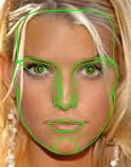
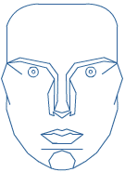

When placed over the photo of Jessica Simpson, we see there is a good fit (that is, the proportions of her face fit the geometrically "nice" proportions of the mask, based on the Golden Ratio).
Her beauty is mathematical!
It is difficult to define perfect beauty as the parameters for a perfect face may vary according to individual preferences.

Similarly, buildings are more attractive if the proportions used follow the Golden Ratio.
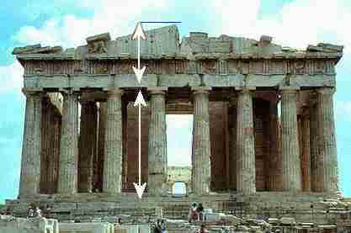
The ratio of the distances indicated is the Golden Ratio.

The Parthenon in Greece
The Golden Ratio also occurs in nature, in the patterns we see in sunflowers, pine cones and spiral shells. This is because one of the best ways to efficiently pack things tightly together is using the Fibonacci sequence.
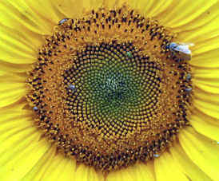
Sunflower
Question 5
  - Find a photo or picture of a famous face full on to the camera.
  - Download this image to the computer and save in your Maths folder.
  - Place the mask over this face. How close is this person to having a perfect face?
  - Explain why this face is/is not perfect.

Question 6 - Measure:
- The width of your face from cheek to cheek and the length of your face from the top of your head to the bottom of your chin. Find the ratio.
- The width of your mouth and the width of your cheek. Find the ratio.
- The width of your nose to the width of your cheek. Find the ratio.
- The width of your nose to the width of your mouth. Find the ratio.
- Put your results in a table and comment on your findings.

