AIS Middle School Student Laboratory Manual

NAME: ...................................

teacher: ...................................

CONTENTS

Topic | Page Number
Introduction | 3
Science Lab Locations | 3
Lab Rules | 4
What to do in an emergency | 4
Lab Apparatus | 5
How to draw lab apparatus | 6
Bunsen Burner License | 9
How to write up a lab report | 10
Glossary | 11

Introduction

In science, it is important to carry out experiments in order to see the theory we have been learning in the classroom put into practice. Many science experiments need to be carried out in a certain controlled environment in order to achieve the correct results, many experiments need certain equipment to work or to view results and many can be very dangerous. This is why we use laboratories in science. Labs are also beneficial when making scientific observations, for similar reasons as experiments.
While working in the lab, there are many different lab apparatus (or ‘tools’) that we use. You will be introduced to a lot of new terminology and to a strict list of rules to maintain a safe environment as we will be dealing with dangerous materials and chemicals.
This manual covers these rules and the basics you need to know in order to successfully write up and safely complete your practical experiments.

Science Lab Locations

The labs are located in the top level of B-Block, above the B-Block main foyer and next to the
computer labs.

Lab Rules

- Students must always follow teacher instructions.
- Safety glasses and lab coats must be worn at ALL times.
- If there is an emergency, students will let the teacher or the lab assistant know immediately. This includes all spills and breakages.
- Long hair must be tied back at all times.
- Enclosed shoes must be worn at all times.
- Students will only walk in the lab.
- Students will stand during experiments.
- Students will not be allowed to carry around matches.
- Food and drink is not permitted in the lab.
- Benches must be cleaned up after use.

What to do in an emergency

In case of an emergency, let the teacher or lab assistant know IMMEDIATELY.

Lab Apparatus

Below, we have a list of some of the various lab apparatus used in the Middle School science lab.
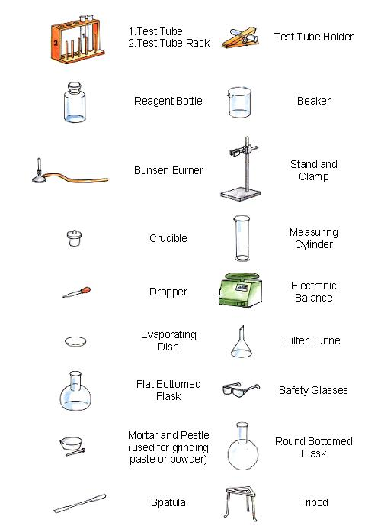

Drawing Lab Apparatus

There are certain rules when drawing lab apparatus and general diagrams in scientific lab reports. It is important that diagrams are correctly drawn and labelled because diagrams are a vital visual aid which are used in lab reports.
Lab apparatus drawings and diagrams must include all parts and be fully labelled:
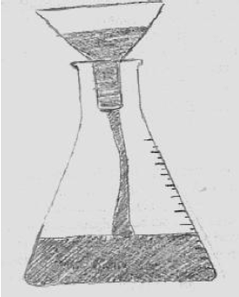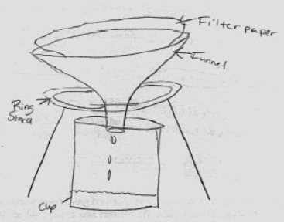
Which of these figures is the most acceptable? Why?

Drawings and diagrams must be large and clear:
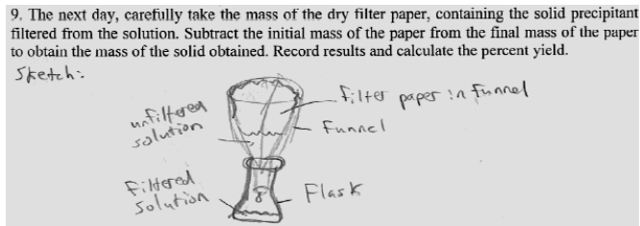
Do you think the above drawing is acceptable? Why/why not?

Drawings do not have to be works of art:
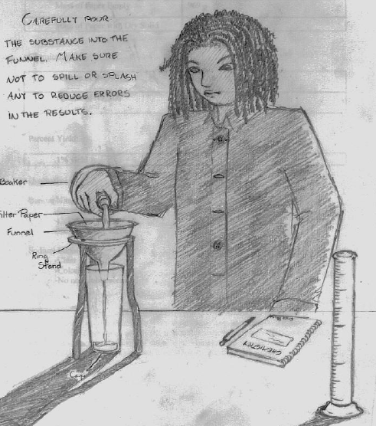
D o you think this drawing is acceptable? Why/why not?

Lab Apparatus Activity

  - Draw a diagram and explain the purpose of each of the following lab apparatus:
Beaker:

Measuring Cylinder:

Stand and Clamp:

Tripod:

Bunsen Burner License

Students are not allowed to use a Bunsen burner in lab experiments unless they first earn a Bunsen Burner License. In order to obtain this license, the student must:

- Know what the parts of a Bunsen burner is
- Know how to safely light a Bunsen burner
- Know what the different flame types are and how to use them

What does a Bunsen burner look like?

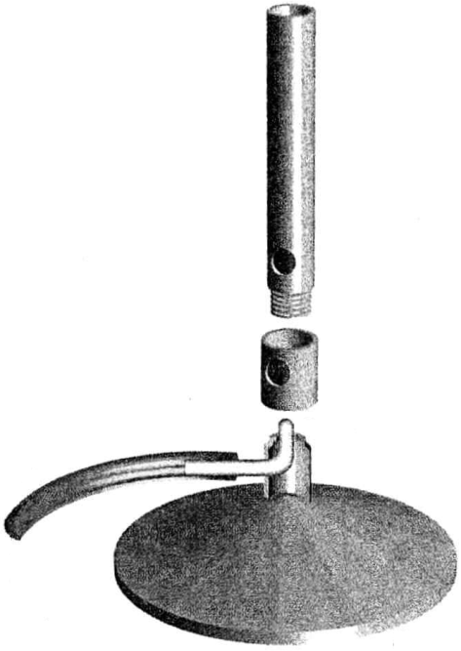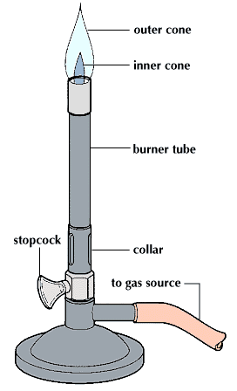
Figure of Bunsen Burner Labelled Diagram of Bunsen Burner

Bunsen burner safety rules

- The rubber tube must be correctly and firmly fitted to both the gas tap and the burner.
- Never touch the barrel of the burner when it is in use. It gets very hot.
- Always move the burner by holding it at the base or by the plastic tubing close to the base.
- Long hair must be tied back.
- Safety glasses must be used.

How do you light a Bunsen burner?

- Place the Bunsen burner on a heatproof mat
- Connect the gas hose to the gas top
- Make sure that the air hole is closed
- Light the match
- Turn on the gas
- Bring the match close to the Bunsen burner. The flame will be yellow (safety flame)
- Gradually open the air hole. The flame will go blue (heating flame)

CLOSED AIR HOLE – YELLOW SAFETY FLAME

OPEN AIR HOLE – BLUE HEATING FLAME

Glossary

Beaker: A container used for stirring, mixing and heating liquids
Bunsen Burner: A small laboratory gas burner.
Controlled Environment: An environment which experiments can be carried out minimising external influences on results obtained.
Crucible: Container which withstands high temperatures and is used for many laboratory processes.
Dropper (Pipette): An instrument designed to transfer small volumes of liquid.
Electronic Balance: Used to weigh solids used in the laboratory – electronic balances in laboratories are very accurate.
Evaporating Dish: A dish which is used where we heat a liquid and collect any solids left behind once the liquid evaporates.
Filter Funnel: A shaped filter which is used to separate solids from liquids.
Flat Bottomed Flask: A glass bottle with a narrow neck and flat bottom which is used to contain liquids in the lab.
Lab Apparatus: Equipment used in a laboratory in order to carry out experiments and observations.
Lab Report: A report we write up in order to document procedures, results and conclusions about experiments and observations carried out in the science lab.
Laboratory: A room which provides a controlled environment where scientific experiments and observations are carried out.
Measuring Cylinder: A tall glass or plastic cylindrical container used to accurately measure liquids.
Mortar and Pestle: Used to crush anything needed for lab experiments/observations.
Reagent Bottle: A bottle used in the laboratory to hold liquids.
Round Bottomed Flask: A glass bottle with a narrow neck and spherical bottom which is used to contain liquids in the lab.
Safety Glasses: Glasses/goggles which are worn in the laboratory in order to protect your eyes from any dangerous or hazardous materials or substances.
Science Experiments: Sometimes referred to as ‘practicals’ or ‘pracs’ for short. These are carried out in order to observe or prove certain happenings in a controlled setting.
Spatula: A thin blade used to move solid substances from one place to the other.
Stand and Clamp: Adjustable tool used to carry beakers and other glass or plastic containers which contain chemicals or other substances.
Test Tube: A thin glass tube with a rounded bottom which is used to carry out small reactions or to contain small amounts of chemicals/substances/materials.
Test Tube Holder: A small tool used to safely hold a test tube – this is usually used when the test tube contents have very high or low temperatures or can be hazardous when held using your hands.
Test Tube Rack: A wooden rack which contains compartments in order to place numerous test tubes side by side to assist with gathering data or making comparisons.
Tripod: A stand used in order to place beakers upon whilst heating its contents.

Name: .........................................
Teacher: ......................................

BUNSEN BURNER TEST

- Label the following diagram:
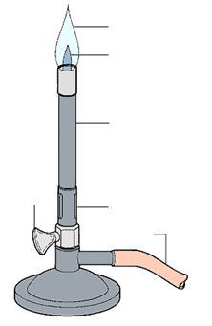

- What is the difference between the yellow flame and the blue flame? Which is the safety flame?
..............................................................................................................................................................................................................................................................................................................................................................................................................................................................................................................................................................................................................................................................................................................................................................................................................................................................................................................................

- Show your teacher that you can safely light a Bunsen burner

