|  |
| --- |
| Middle School |
| **STUDENT NAME:**   **CLASS: _______**  **TEACHER NAME:** |

|  |  |  |  |
| --- | --- | --- | --- |
| **UNIT: Measurement**  **ISSUE TOPIC Trigonometry and Pythagoras – Indirect Measurement**  **ASSESSMENT TASK: Investigation**  **ASSESSMENT DESCRIPTION: Using trigonometry and Pythagoras’ theorem, students participate in the planning phase of an Outdoor Education project at AIS.**   * Knowledge and Understanding * Thinking and Reasoning * Communicating * Reflecting   **CONDITIONS OF ASSESSMENT: 1 week – class time may be used.** | |  | **Mathematics** |
|  |
| **YEAR 8/9**  **2010/2011**  **TERM 2**  **TASK: Investigation** *‘How Do You Measure Up?’*  ***Measurement*** |
| **SUMMARY OF RESULTS** | |
| **CRITERIA ASSESSED** | **STANDARD** |
| **KNOWLEDGE & UNDERSTANDING** |  |
| **THINKING & REASONING** |  |
| **COMMUNICATING** |  |
| **REFLECTING** |  |
| **OVERALL RESULT** |  |

‘How Do You Measure Up?’

**Context :**

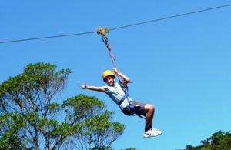The SRC at the Australian International School have requested that more equipment be installed in the school for exercise and recreation. The Physical Education Department have decided that to take this idea further by submitting for approval, a ‘Phase One’ plan for an outdoor education centre at the school, which includes a rock-climbing wall in the gym and a ‘flying fox’ or ‘zip line’. As this is a student-initiated idea, and you have been studying trigonometry, the PE Department have requested that students assist in the planning phase of the project.

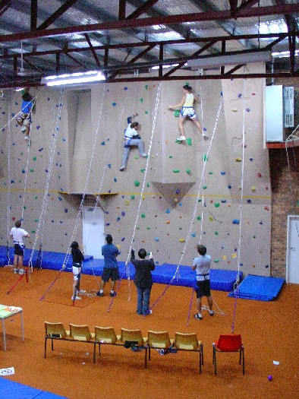

Indoor climbing wall ‘Flying fox’ or ‘Zip line’

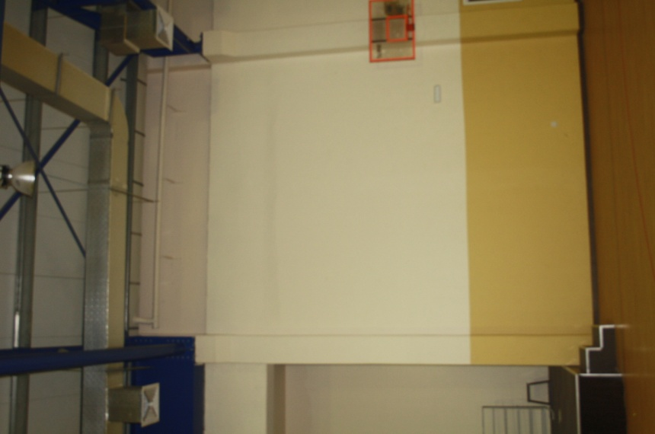Your submission will consist of 3 tasks. In Task 1, you need to prove that you have a solid grounding in the mathematics behind your calculations, by researching the history and theory behind the development and uses of trigonometry and Pythagoras’ theorem. In Tasks 2 and 3, you need to calculate accurate measurements for the PE Department through the use of trigonometry and Pythagoras’ theorem.

**The Brief**

**Task 1** – **Research** the development of trigonometry and Pythagoras in history. Who discovered the principles? When? How did this impact the world at that time? How are these concepts used today? Why are they important?

**Task 2** – *The Rock Wall* – The climbing wall will be installed in the gym on the right hand side of the stage as you are facing it. There is a blue beam above the stage. The climbing wall will finish at a height equivalent to the base of this blue beam. **How high will the climbing wall be?** You are to independently **identify** and **gather** the relevant measurements, **calculate** your answers and **present** your findings as a table, including relevant diagrams.

The climbing wall will finish here.

**Task 3** – *The Flying Fox* – An enclosed ladder will be built on the outside of the gym next to the pool windows on the junior oval side. This ladder will lead to a platform to be built level with the roof. A 3 metre pole will be installed at the rear of the platform. A wire will extend from the top of this pole to the horizontal bar of the cricket nets on the opposite side of the junior school oval. A harness will hang from this wire. This will make the ‘flying fox’ or ‘zip line’.

3 m pole

The wire will finish at this bar.

Platform

Ladder

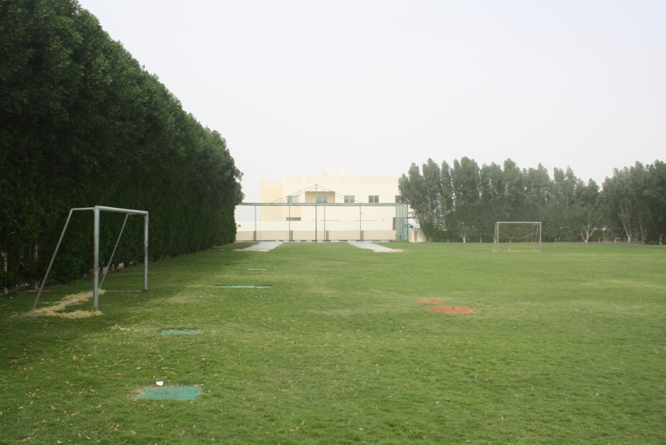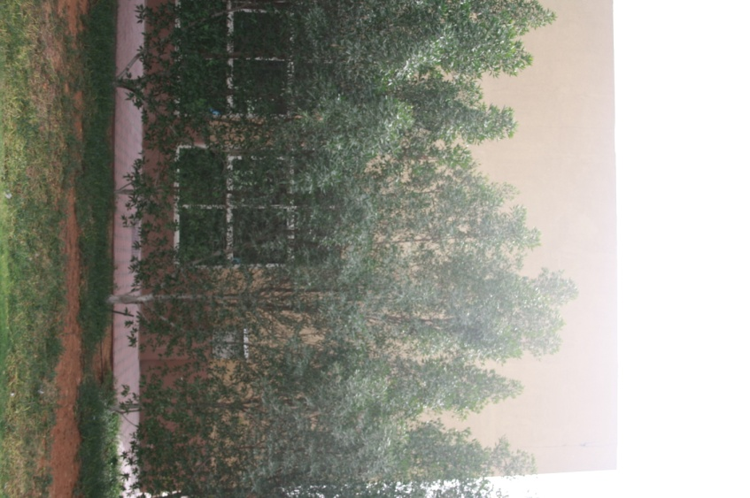

1. **Calculate the length of wire required.**
2. **Calculate the angle of the wire in relation to the ground.**

**Points to Note:**

* **Draw** and **labe**l a diagram for Task 2 and Task 3 (assume the wire does not sag).
* **Identify** any sources of possible error in your calculations. Are these errors within a reasonable range? How could small errors have large effects on your calculations? Give examples.
* [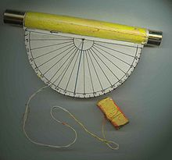](http://en.wikipedia.org/wiki/File:Clinometerlow.jpg)To successfully complete this task, you will need to construct a clinometer (or inclinometer). <http://en.wikipedia.org/wiki/Inclinometer>
* Ensure you include appropriate **referencing** for Task 1.
* Information presented should use appropriate **ICTs** ie Word Processing, Powerpoint, Excel etc as needed.
* A key to performing at a high standard or above in this investigation is to **demonstrate independence** in identifying, gathering, calculating and presenting.